

**Local Foods Endeavors within Region Five**

The geographic areas encompassed in this initiative are five counties in central Minnesota with a total population of 162,000: Crow Wing, Cass, Morrison, Todd and Wadena Counties. Part of the region is very rural and comprises two of the poorest counties in the state (Todd, Wadena), made up of primarily agricultural communities, while two of the region’s counties (Crow Wing and lower Cass) make up the majority of the population and growth. The largest city in the region by a factor of 3, Brainerd/Baxter in Crow Wing County, has been ranked one of the fastest growing micropolitans in the nation. The rapid growing lake counties have a seasonal population that expands from 10,000 to nearly 60,000 which can be considered an asset in the development of a successful Local Foods HUB.

The history set forth in this paper is intended to inform partners of regional activities performed by numerous regional champions, whose purpose is advancing the supply and use of locally grown foods.

**2007** Executive Director of the Region Five Development Commission (R5DC) joined the University of MN Regional Sustainable Partnerships: Pine and Lake Country Local Food Workgroup to identify how we could collectively improve access to locally grown commodities, and continued this activity through 2008, assessing the needs of this recognized economic opportunity.

**2009** concentration was given to the **producer side**:

* + **R5DC Co-Sponsored our first Local Foods AmeriCorps VISTA (Vollunteer in Service to America)** with UofM Regional Sustainable Development Partnership. Considerable amount of research was conducted by the AmeriCorps VISTA regarding national models of local foods distribution systems for consideration of the Pine and Lake Country Local Foods working group. (Supported by the MN Farmers Union and the Initiative Foundation)
  + **Surveyed growers** to identify willingness to produce more local food for schools, hospitals, and restaurants, had more than 150 growers interested (All growers have less than 250 acres, many with less than 50).
  + **Co-hosted forums** to teach growers requirements to sell commodities. Hosted workshop on how to access USDA value added Ag NOFA (22 growers).
  + Obtained funding and **Published 5000 copies of a Pine and Lake Country Local Foods Catalog,** distributed to region. Supported by R5DC and the Regional Partnerships.
  + **R5DC interviewed 22 chefs** to gage interest in sourcing more locally grown foods, had high level of interest and commitment.
  + **Started 9 community gardens**, some of which are now selling food at farmers markets. Teamed with Extension Services and Master Gardeners to provide training to growers. (Supported by Statewide Health Improvement Partnership “SHIP” funding)

**2010** we focused on the **buyer side** by developing relationship with institutions interested in sourcing locally grown foods.

* + Hired second Local Foods AmeriCorps VISTA, workplan supported building the demand side of the regional local food HUB.
  + We **met many times with 3 hospitals**, one in particular which was sourcing nearly 2% of their food from local growers and increased commitment to sourcing up to 15% once distribution is in place.
  + **Chefs began to meet regularly** to exchange buying BMP’s and to understand the fair market rate of locally grown commodities.
  + **Growers worked for FREE** in some of the restaurants a few hours a week to better understand the kitchen limitations the chefs are faced with and to build relations.
  + ***Speed Dating event*** *with growers and Schools, hosted by the Regional Sustainable Partnerships. MANY introductions started through this event. Met Champions at this event. Noteably, Arlene Jones, Farm on St. Mathias and Brainerd School District food service Manager; Collette Polkamp.*
  + **Farm 2 School research** conducted by The Regional Sustainable Partnerships. Found at: <http://regionfive.org/departments/community-development.html>



* + **Growers gave school cafeteria presentations,** to assist in the educational opportunities of students for those districts who would source from local growers. Teachers loved this partnership!
  + **Met many times with superintendents and kitchen managers** of several school districts to gauge interest. Resulted in great enthusiasm with the School Board of largest school district in the region (School District 181) committing to sourcing very specific quantities of locally grown foods, should a system be launched to deliver foods regularly…..i.e., a distribution system.
  + VISTA convened a committed group of growers, community Ed, public health and school district representatives to discuss how we could pursue the development of a model distribution system. **We decided to** create a workgroup to complete a distribution system and climate controlled storage business plan and feasibility.

**2011** we created a Businss plan and sought research and supportive sources:

* + January 4, 2011 **met with Rural Development** to discuss potential USDA Rural Development programs that align with regions local food goals.
  + Todd County Board of Commissioners agreed to pursue the **bonding process of $500,000.00 to build a Community Kitchen** at the Senior Center in the small town of Eagle Bend. This town is centrally located in the county and many growers would have access to adding value to their commodities (value added AG) and could benefit from a distribution system as the market demand increases.
  + Partnering as a workgroup member in developing the business plan, the opportunity was presented to the collective to **lease warehouse space from School District 181** at a very competitive rate. Conversations with Central Lakes College began regarding similar opportunities. Schools are seeking all sort of ethical alternatives to income generation in these economically distressed times. This effort aligns the schools with the local foods efforts and builds sustainable and lasting partnerships.

**2012** we have expanded the “demand” and more private sector agencies want to participate in the local foods endeavor:

* + Offered **microloans to ag based businesses** to scale up production in order to meet the increased demand. (USDA RMAP program)



* + Completed the business plan that formalize the **legal status of “SPROUT”** as a MN non-profit and a private LLC. The plan was completed by the Central Lakes College Small Business Development Center; Julie Anderholm, a private consultant; BJ Allen with JBJ World and Arlene Jones with the Farm of St. Mathias. Support was provided by Region Five to complete this work. Found at:

<http://regionfive.org/departments/community-development.html>

* + **The SPROUT collaborative consists of** small volume growers, School Districts, Chefs and resort/restaurant managers, community college, sustainable farming association, government, public health, food shelves, 2 health care institutions, community ED and food related social advocacy groups.



* + We have a **new VISTA working on creation of a “Food Recovery Project,”** a gleaning program that allows low income families to harvest unused “seconds or culls” from local farms or for this locally grown and healthy food to enter into the food shelf systems.
  + More research completed on the effect on **Food HUBS** from the UofM – supported by the Initiative Foundation. Found at: <http://regionfive.org/departments/community-development.html>



* + Feasibility Study and business plan formation completed for the value chain food hub **and** construction of additional **food processing facilities**, paid for by AURI, the Initiative Foundation, the University of Minnesota Central Region Partnership, and Happy Dancing Turtle. Found at: <http://regionfive.org/departments/community-development.html>



* + The UofM Extension has a full time staff person dedicated to providing Local Foods **technical assistance to growers and buyers for the next 4 years** as a result of a grant from the MN Dept. of Health.
  + USDA funded Region Five with and RCDI to move forward this project and 9 others from the RR Plan toward implementation.
  + A local restaurant, Prairie Bay, has purchased a **Food Truck** that will use as much locally grown commodities as possible. Recent grants support this truck to travel to *very rural* Food Desert areas as a way to provide education about how to prepare locally grown produce and then work to establish the distribution plan to GET LOCALLY Grown foods to those areas on a regular basis.

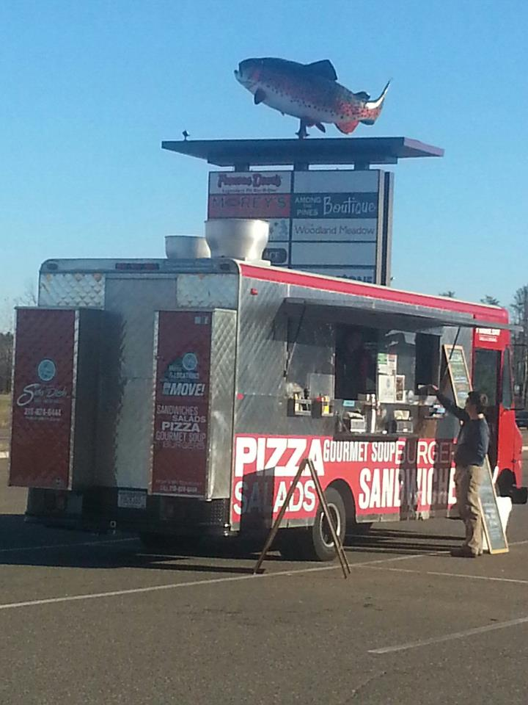

1. – Connecting with supportive partners for our self-sustaining model.

Our Local Food value-added agricultural project represents a priority area selected by the region through the HUD-DOT-EPA-funded Sustainable Communities Regional Planning process.

The project has three components:

1. Establish a regional food hub for the aggregation and distribution of locally produced foods;
2. Extend the growing season through proving the use of locally manufactured solar thermal collectors combined with high tunnels; and
3. Coordinate outreach, education, and technical assistance activities that will expand the availability of local foods in the region, targeting both farmers and consumers.

* Local food Champion Arlene Jones, the SPOUT food HUB manager was selected to partake in the BUSH Foundation Leadership training program to build the local food hub infrastructure.
* 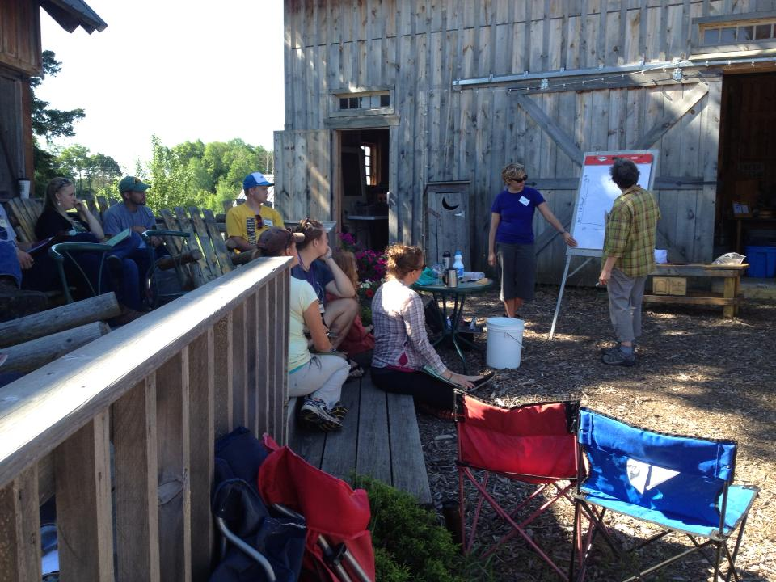SPROUT and Arlene Jones hosted 25 growers at a Good Agricultural Practice workshop, instructed by the University of Minnesota in June of 2013 (see photo)

Local Foods realted MICRO-LENDING activity has been on the rise. (micro $ used for a portion of the lending needs)

* Long Prairie MN – Value added business package with the local food theme including growth of the local foods; processing, distribution and sales using the Latino heritage as owners, workers and promoters in the Long Prairie, Todd County area.
* Wadena MN – Value added business package with a bakery theme.  A new business start-up in a closed bakery facility.  Embracing the local food theme for the local growth, processing, distribution and sales of product.  This format also includes diversification into providing a home base for the local senior’s in-home food delivery program – Meals on Wheels.
* Menahga MN – Using a unique existing value added food footprint of an existing local foods grocery business, the addition of a health bakery goods extension of that business allows this established business the opportunity to expand into a publically requested diversification of local foods in the Wadena County Area.

**2014**

Building relations with Latino growers through Latino Economic Development Corporation and Amish growers. Up to 40 growers currently engaged

Delivered nearly 100,000 pounds of locally grown fresh produce this last year.

(Many new buyers; Schools, hospitals, restaurants etc.)

Local Restaurateur; Prairie Bay visited many food deserts with their Food Truck; “SIDE DISH” and provided chef demonstrations of how to prepare underutilized fresh produce. Intercept surveys conducted at locations, data collected.

Bio-fuel delivery truck converted and maintained by Central Lakes College mechanics class.

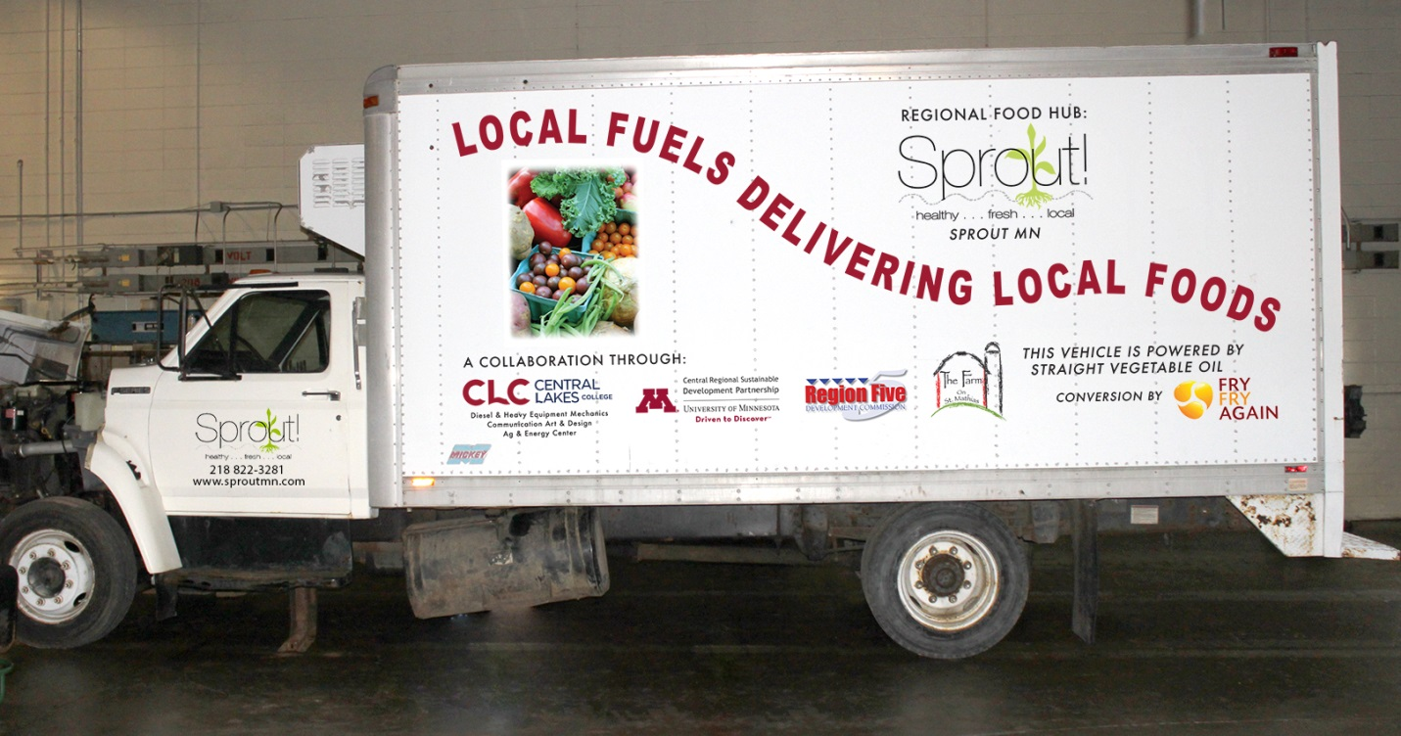

Solar Thermal High Tunnels at two grower sites. The food grown 365 days a year is sold through SPROUT. Work to get more at the Franciscan sisters convent in Little Falls as partnership with School District and Central Lakes College.

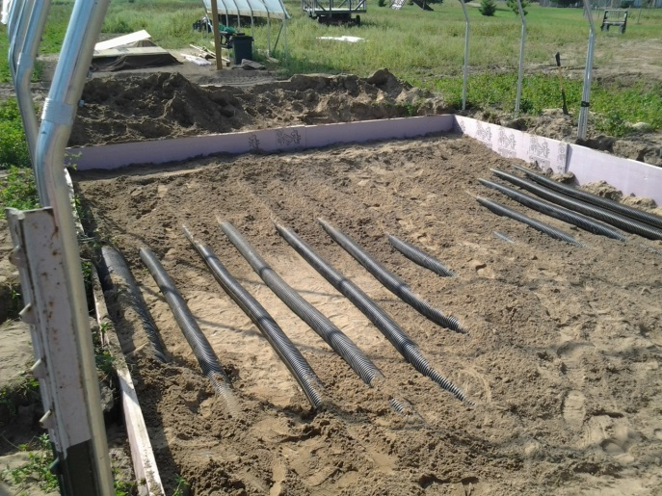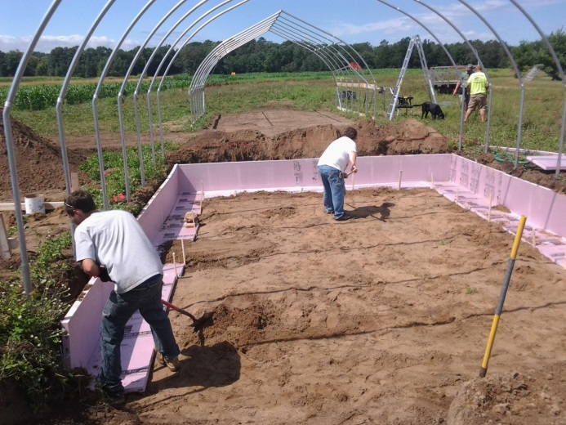

Feasibility studies for 3 Food Processing Facilities that are part of the “SPROUT Distribued Local Food Network “. Each processing facility hase with unique qualities at each such as;

New AG Instructor that support K-12 schools to deliver student training at a local catholic convent farm in partnership with CLC and National Joint Powers Alliance.

Facilitated conversations by USDA, SPROUT is learning from 4 other local food Hubs throughout the nation.

Hunger Free Minnesota is learning if there are opportunities to create a pilot program with Lakewood Hospital, SPROUT and CSA’s.

A Health and Recreation Alliance comprised of SPROUT, the Gull Lake Sailing School, Mt. Ski Gull and the Lakeshore Conservation Club to provide healthy food and active living opportunities for Service Member Families. Perscriptions written by family doctors for CSA’s givne to servicemember families who’s health ratings have a higher probability of improvement through a healthy diet supplied by local grower Co-op “SPROUT.”

Upper Lakes Foods conversation to develop distribution relations.

Central Lakes College – Center for excellence focused on food and fuel.

Video production of Arlene Jones representing SPROUT as a regional Champion-

[**http://www.youtube.com/watch?v=7axBvi1x42I&feature=youtu.be**](http://www.youtube.com/watch?v=7axBvi1x42I&feature=youtu.be)

|  |  |
| --- | --- |
| Secured grant activity: | **Amount** |
| Regional Sustainable Development Partnerships - SPROUT | $ 50,000.00 |
| BUSH Fellowship - Arlene Jones | $ 75,000.00 |
| Otto Bremer -SPROUT | $ 50,000.00 |
| Northwest Area Foundation - SPROUT | $ 75,000.00 |
| Happy Dancing Turtle –SPROUT (awarded, not funded to date) | $ 5,000.00 |
| Regional Sustainable Development Partnership – Side Dish Food Truck | $ 35,000.00 |
| MN Dept of Ag- feasibility study Pine River | $ 10,000.00 |
| MN Dept of Ag – feasibility study in Little Falls | $ 10,000.00 |
| MN Dept of Ag- Farm St. Mathias processing facility | $ 31,260.00 |
| AURI study - HDT | $ 30,000.00 |
| Initiative Foundations - cura caps, processing feasibility | $ 22,000.00 |
| TOTAL | $ 393,260.00 |

Denied:

Minnesota Department of Agriculture - $70K

SUNDRA Foundation - $180K

HHS - $300K

BCBS - $30K

Ben & Jerrys $5k

St.Joes Foundation $5k

Cote Founation -- $35k

With over 160 food distribution models currently in operation around the nation, we have benefited from learning opportunities through these various models, and have patterned our model from some of these successful examples in building a value chain food hub.

Let’s make the assumption that we can all make the connections to the value of creating a regional local food economy; reduction of VMT’s, increased incomes of small agricultural producers (wealth creation), reduction of sprawl (keeping ag land - ag), increased access to nutritional foods (health benefits), making the URBAN- RURAL connection, adding to our QUALITY OF PLACE and this list goes on and on. Several economic impact studies have been published regarding the positive community multiplier as a result of sourcing local foods.

As we continue efforts to build new partnerships we will document our process and create user friendly resources that will enable other areas to replicate this work. We are particularly interested in assisting immigrant populations into this model and our group is COMMITTED to assisting other regions who are interested in replication of a successful model.